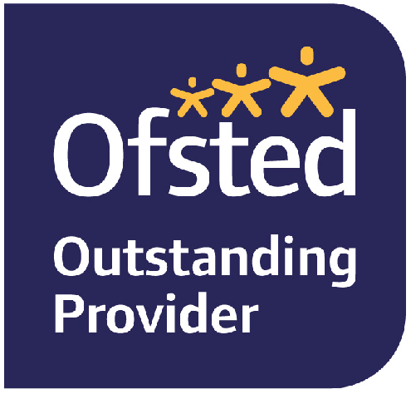   | 
Lunchtime Kitchen Assistant
Start Date: September 2026
Actual Salary £10,920.00 per annum, 39 weeks per year, 10:00am – 14:00 pm, 20 hours per week.

Heathermount is a day school, owned by Cavendish, set in 12 acres of beautiful grounds in Ascot, Berkshire. In October 2024 we had an Outstanding Ofsted inspection.

We provide a high-quality education for students aged 5-18 who have a primary diagnosis of Autism. All our students have an Educational Health & Care Plan. We are a well-resourced school with small classes with students supported by a team of educational and therapeutic staff who work in unison to achieve the best outcome for our learners.

We are seeking a reliable and enthusiastic Kitchen / Lunchtime Assistant to join our team.

In this role, you will support the day-to-day running of the kitchen and assist with lunchtime service for children. Duties include food preparation, cleaning, stock organisation, and serving meals while helping to create a safe, positive, and hygienic environment.

The ideal candidate will be a team player with a positive attitude, good communication skills, and the ability to work well with children. Previous experience is desirable but not essential, as training will be provided. If you are hardworking and dependable we would love to hear from you!

We are a forward looking and ambitious school with a passion for making a difference to the lives and education of our young people and our hard working, talented staff.

Why work for us:
- A chance for you to be creative and have an impact on the learning of our students.
- To work alongside a friendly and passionate team of professionals.
- We provide a comprehensive CPD programme to aid you in developing your career further.
- To work in a setting that has achieved Advanced Autism Accreditation.
- The chance to work in a school that received an “Outstanding” Ofsted inspection in October 2024.
- A competitive salary and contributions to your pension.

Benefits included:
- Performance related bonus
- Life Insurance cover @ 2 x your basic salary
- Subsidised lunches
- Employee assistance and well-being support and advice
- Free onsite parking
- Long service awards
- Cycle to Work Scheme
- Pension scheme
- Livi GP services
- Blue light card
- Bright exchange (discount scheme)
Please do not hesitate to call the school for an informal chat or come and visit us and meet our inspiring, wonderful young people and our hard working, talented staff. We welcome interest from colleagues from both mainstream and special or alternative provisions.

Please contact us for further information, on 01344 875101 or by email to recruitment@heathermount.co.uk.

Safeguarding and promoting the welfare of children is everyone’s responsibility. Everyone who comes into contact with children and their families has a role to play. Heathermount School is committed to safeguarding and promoting the welfare of children and young people and expects all staff and volunteers to share this commitment and carry out their safeguarding responsibilities as per the job description and personal specification for their role.

Any successful applicant will be required to undergo the child protection screening appropriate to the post, including an enhanced disclosure from the DBS (Disclosure and Barring Service), Barred List check, online searches, and a minimum of two references from previous employers.
For more information about the DBS please see: https://www.gov.uk/disclosure-barring-service-check.
This post is not exempt from the Rehabilitation of Offenders Act (ROA) 1974.

We evaluate applications on receipt and may contact suitable candidates for interview before the closing date. Please note, the role will close as soon as a successful candidate is appointed so early application is recommended.

Closing Date: 19th August 2026
Interview date: As soon as possible

